SANDALS RESORTS AND SONY MUSIC NASHVILLE SALUTE SERVICE MEMBERS WITH MEMORIAL DAY WEEKEND BOOTS ON THE BEACH BENEFIT EVENT
~ Country Music Stars Chris Young, Jerrod Niemann, Tyler Farr, Logan Mize, Josh Dorr and Cam; CMT’s Katie Cook; and widow of American Sniper, Taya Kyle Raised Funds for Boot Campaign at Sandals Ochi Beach Resort in Jamaica ~

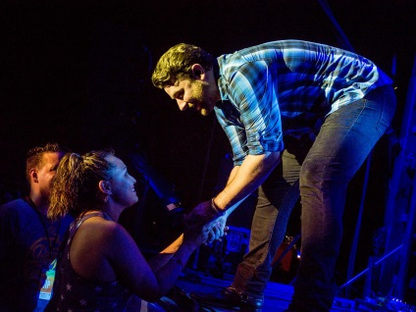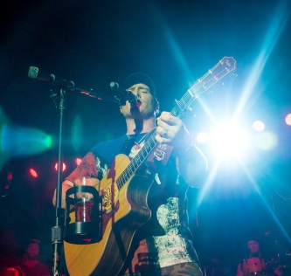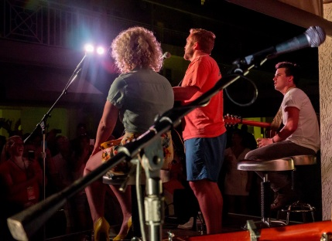
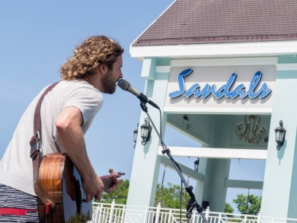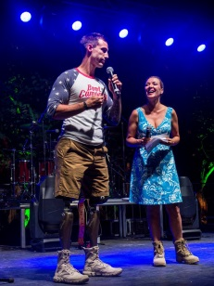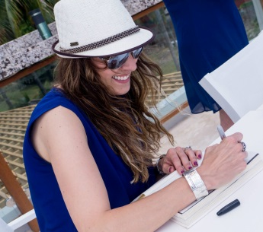

MONTEGO BAY, Jamaica / NASHVILLE, TN (June 2, 2015) – Coming off of National Military Appreciation month in May, Sandals Resorts continued its longstanding history of supporting U.S. service members by teaming with Sony Music Nashville to host the Boots on the Beach Vacation over Memorial Day weekend at Sandals Ochi Beach Resort in Jamaica. A country music celebration to benefit Boot Campaign, the event raised more than $10,000 toward promoting patriotism for America and the military community while providing assistance for the unique challenges service members and their families face during and post-service.

“This weekend was a culmination of our ongoing support for U.S. service members and their families. It was our privilege to be part of an event which raised awareness and funds for such a worthy cause. These people have given so much. It's an honor to do something special for them,” said Gordon “Butch” Stewart, Chairman of Sandals Resorts International, parent company of Sandals Resorts.

“Country music has always had deep ties with the men and women serving our nation,” remarked Paul Barnabee, Sony Music Nashville’s Senior Vice President, Marketing, “and on behalf of our artists and all of us at Sony Music Nashville, we were very proud to partner with Sandals Resorts, Funjet Vacations, Alliance Connection and the Jamaica Tourist Board to present an event whose benefits honor the true spirit of Memorial Day.”

Hosted by Katie Cook of Country Music Television’s Hot 20 Countdown, and with appearances by Boot Campaign Ambassador Taya Kyle, widow of American Sniper Chris Kyle and Boot Campaign COO Joey Jones, the weekend kicked off at Sandals Ochi’s Sundowner Bar with an acoustic jam session by up-and-coming artists Logan Mize, Josh Dorr and Cam. Guests were also treated to performances by platinum-selling artists Chris Young, Jerrod Niemann and Tyler Farr. In addition to the star-studded performances, the weekend featured exciting events with the country artists such as the Sandals Beach Olympics, a live performance pool party with American Idol finalist Casey James and a silent auction to benefit Boot Campaign. The holiday weekend also included VIP meet-and-greets and excursions for the military couples, including an Island Routes catamaran cruise, visit to Villa Rio Chico with the Sandals Foundation and a tribute performance at the Jamaican home of country music legend Johnny Cash, where Sony Music honored his musical success at Sony with a plaque commemorating sales of more than 14 million records.

As part of the celebration, six deserving military couples were surprised with the vacation of a lifetime to attend Boots on the Beach Vacation courtesy of Funjet Vacations, known for delivering unparalleled travel experiences at an exceptional value. One of the couples, Tatiana & Phillip McGill of San Antonio, Texas, both Marine Corps veterans who met during their tour, were married in 2005 in a justice of the peace ceremony. Never having a traditional wedding or honeymoon, their Sandals Ochi trip was a welcomed addition to their love story and even featured a ‘first dance’ serenaded by Chris Young. In addition to the military couples, 20 sweepstakes winners were given a once-in-a-lifetime opportunity with the Funjet Vacations Do Something You'll Never Forget Meet and Greet VIP Experience, offering one-on-one time with all the artists.

Sandals Resorts has a long tradition of honoring those in service, a commitment begun by Stewart following the Gulf War when Sandals donated vacations worth $1 million to returning troops, and then again with Operation Relax, which doubled the offer to troops returning from Iraq. Today, Sandal Resorts offers a 10% savings to all active duty, reserve or retired members of all branches of the U.S. Military and their spouses.

Guests, sponsors and musicians also got a sneak peek at the all new Sandals Ochi Beach Resort, Sandals’ largest and Jamaica’s newest resort to-date. The completely renovated resort was rebuilt to offer a dynamic beach experience complete with stylish beach club vibes, chic exclusivity and innovative culinary concepts. Sandals Ochi Beach Resort features a fresh, modern design aesthetic along with seven uniquely new Gourmet Discovery Dining options, a fresh, trendy Ochi Beach Club, reinvented resort entertainment, upgraded luxurious accommodations and more.

Boots on the Beach Vacation was produced in association with Sandals Resorts, Sony Music Nashville, Alliance Connection Productions, All Access Experience, Jamaica Tourist Board, Funjet Vacations and of course, Boot Campaign.

Video link for media: https://drive.google.com/file/d/0B2hjbLz7tjCqUHU3Tm5Wa0ZoeFU/view?invite=CLjb0uEC

# # #
For Sandals, contact:
The Decker Royal Agency
Stacy Royal Devyn Barker Cathy Decker
646-650-2185 646-650-2186 646-650-2188
stacy@deckerroyal.com devyn@deckerroyal.com cathy@deckerroyal.com

For Sony Music Nashville, contact:
Allen Brown or Bob Foglia / Sony Music Nashville
allen.brown@sonymusic.com / bob.foglia@sonymusic.com
615-301-4300

