
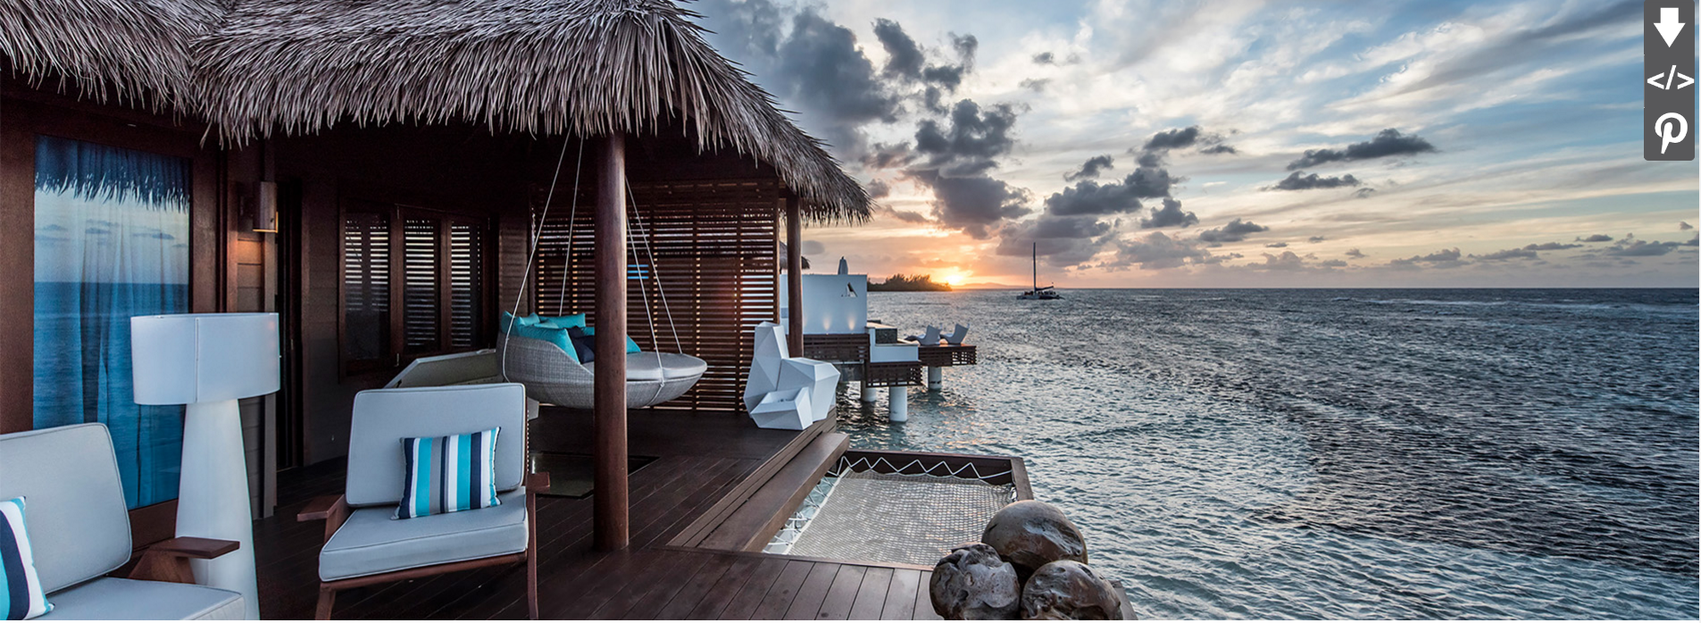

SANDALS RESORTS ANNOUNCES FUTURE PLANS FOR OVER-THE-WATER SUITES AS IT DEBUTS THE FIRST OF ITS KIND IN THE CARIBBEAN

~Much-Anticipated Villas Open with Additional Over-the-Water Suites Slated for 2017 and 2018~
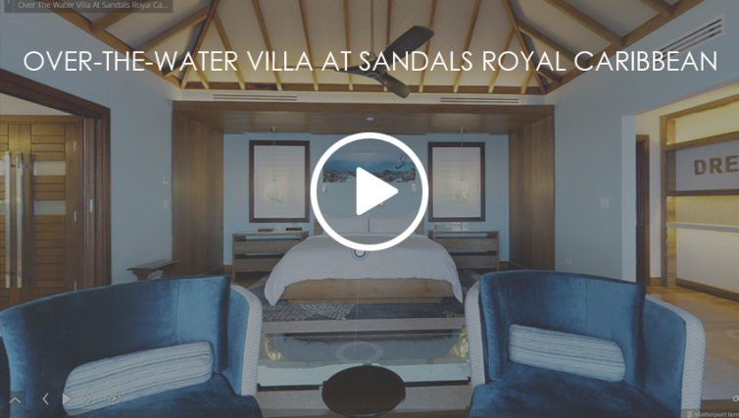
MONTEGO BAY, Jamaica – December 5, 2016 Debuting the Caribbean’s first-ever Over-the-Water Villas at Sandals Royal Caribbean in Montego Bay, Jamaica on December 1, Sandals Resorts is announcing the development of additional Over-the-Water suites at new locations throughout the region. Citing unparalleled demand and a drive toward continued innovation, the suites will be unveiled at select Luxury Included® resorts throughout 2017 and 2018, including 12 additional Over-the-Water Bungalows at Sandals Royal Caribbean slated to open in March 2017.
“I have always said that being out on the water is where I am happiest, and with these suites, guests can experience a direct link to the Caribbean Sea,” said Gordon ‘Butch’ Stewart, Chairman and Founder of Sandals Resorts. “Being first is nice, and as a category leader we’ve enjoyed a lot of firsts – but what is more important is that we continue to evolve, continue to innovate, continue to upend the notion of what an all-inclusive can be and of course, continue to exceed the expectation of our guests.”

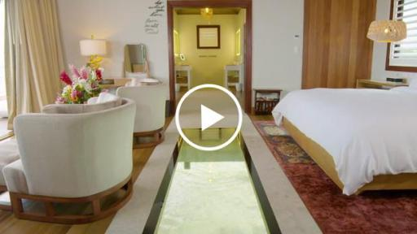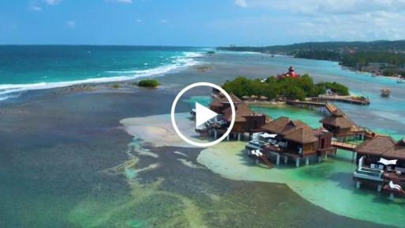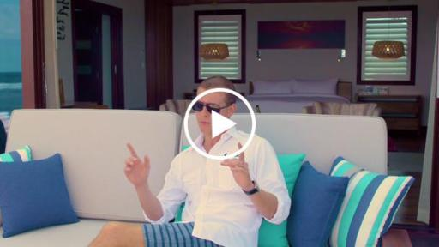
Inside the Over-the-Water Villas Aerial view of the Over-the-Water Villas Interview with Sandals Resorts’ CEO
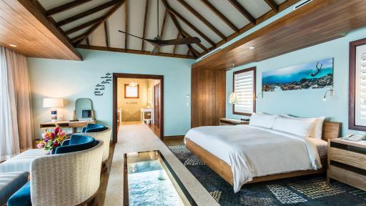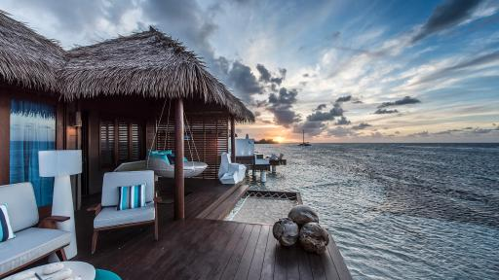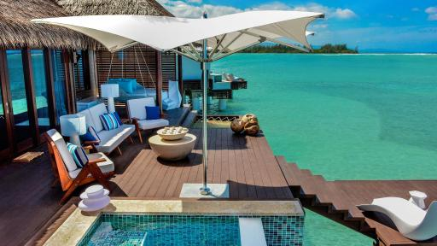
Interior view Sunset exterior view Exterior view

The first of its kind in the region, the recently opened Over-the-Water Villas at Sandals Royal Caribbean convey an intimate connection to the Caribbean Sea and represent a new level of innovation for the Luxury Included® company. Each of the five villas has a different design, representing the Feng Shui elements: Wood, Water, Fire, Earth and Metal, illustrated through unique elements from warm wooden pendants and underwater art pieces to mirrored and metallic accents. Merging the interior and exterior spaces through multiple expansive glass doors, couples can admire the majestic beauty of the ocean from their private infinity pool, over-the-water hammock, glass floor panels or the suite’s stylish king-size beds made from teak adorned and soft Egyptian linens and plush pillows for the ultimate sleep.
Beyond the views, guests staying in the newly debuted Villas have access to unparalleled services and exclusive amenities from 24/7 butler service, trained in accordance to the exacting service standards of the Guild of Professional Butlers, and personalized in-room dining to private yoga classes and direct resort access via a “Royal Duffy” luxury boat. Additional villa features include: personal airport greeting with expedited immigration; private luxury resort transfers; House of Marley sound system; welcome gift, including a branded beach tote and towel set; Molton Brown bathroom amenities, free WiFi and more.
Built along a beautiful wooden boardwalk, the Villas are connected to land at Sandals Royal Caribbean’s offshore private island, Sandals Cay. An experience onto itself, the island features a newly redesigned pool with a signature pool-bar; two restaurants including The Jerk Shack, offering authentic rustic cuisine and Royal Thai, capturing the flavors of the East; and number of nestled hideaways. Located on the northern shores of Jamaica, Sandals Royal Caribbean Resort & Private Island a mere 10 minutes from Montego Bay’s Sangster International Airport. The hotel features 227 rooms and suites and in addition to the Over-the-Water Villas and Bungalows, recently debuted newly renovated Romeo & Juliet Suites and Windsor Beachfront Club Level rooms. The Luxury Included® resort also features 8 on-property restaurant and bars, with access to 12 additional 5-Star Global Gourmet dining experiences at Sandals Montego Bay and Sandals Inn through Sandals Resorts’ “Stay at One, Play at Three” program.
Rates for the now open Over-the-Water Villas begin at $1,435 per person/per night, while the Over-the-Water Bungalows are available for booking ahead of the 2017 debut, with rates beginning at $1,100 per person/per night. Additional details regarding forthcoming development plans will be revealed in the coming months. For more information or to book these villas, please visit www.sandals.com/main/royal/rj-over-the-water-suites.
###
Contact:
Devyn Barker
646-650-2186
devyn@deckerroyal.com



